**Assignment 5**

Create a web dashboard to take user input for scheduling the pump controller (date & time). store the data in the Cloudant DB.

you can use Form Nodes in dashboard nodes to take user input.

NODE-RED:

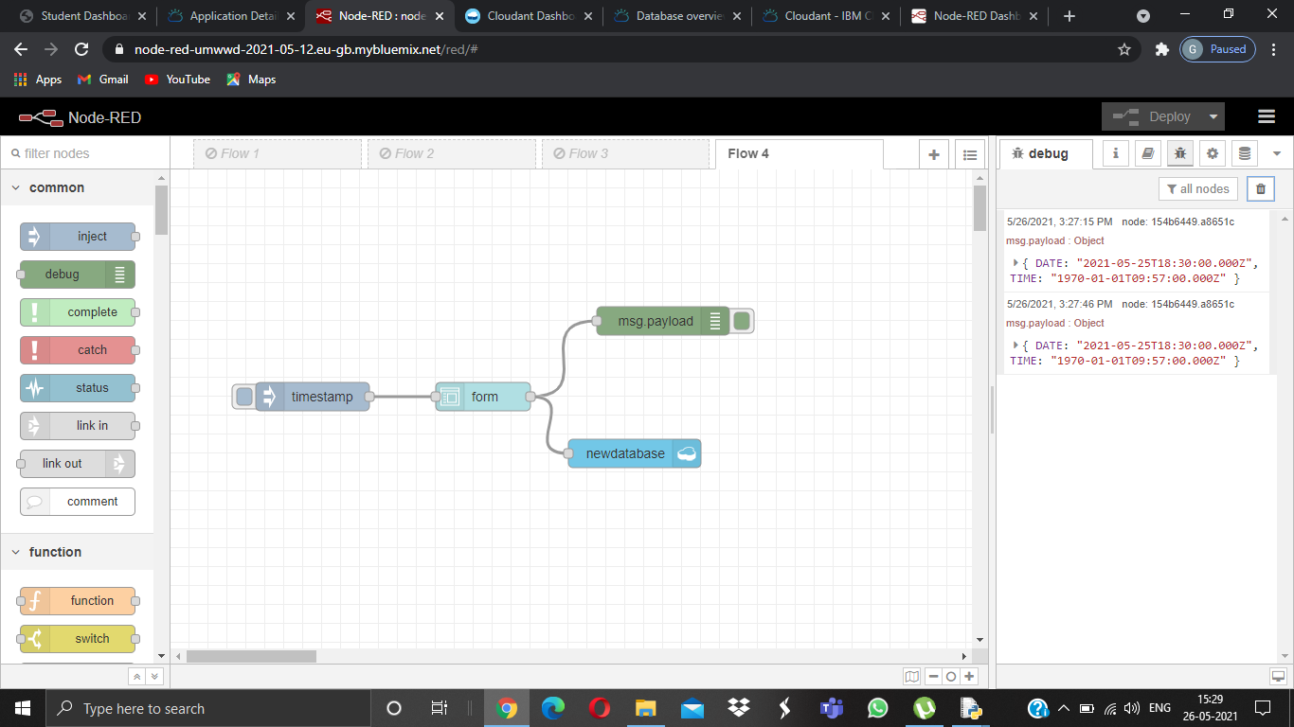

DATABASE OUTPUT:

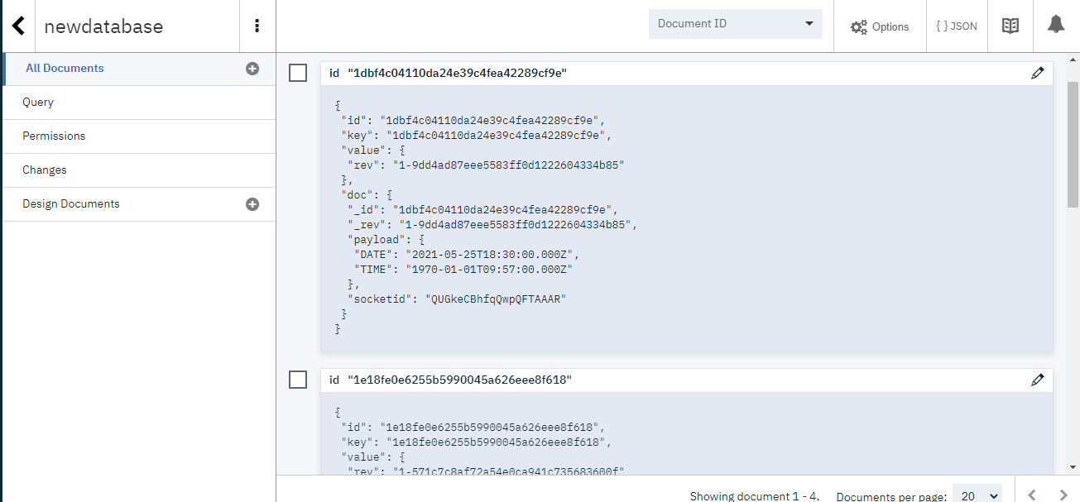

NODE RED UI:

